Database development in SQLite

Using the data from the Blue KC zips, counties, and state.

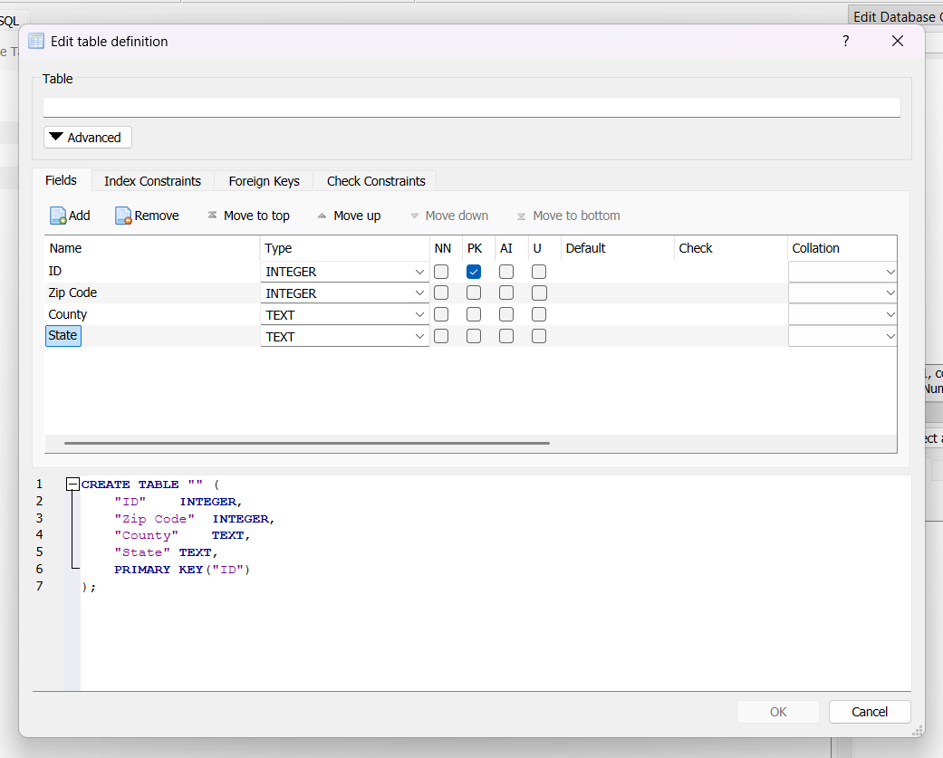

Image of the DB Browser for SQLite GUI interface.

Creating a new table to store the information.
SQL Code to create:
CREATE TABLE "BlueKC" (  "ID" INTEGER,  "Zip Code" INTEGER,  "County" TEXT,  "State" TEXT,  PRIMARY KEY ("ID")  ); | This is to create a new table in my test database to store the basic information.  I could have only the zip code as the primary key, but there are a few zip codes that span county lines. There I also 1 zip not in the state. For those cases, it was better to have a unique ID.

Execution finished without errors:
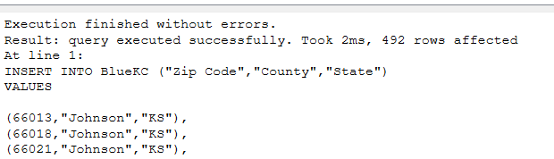

I could have added the zips and counties as the primary keys along with auto ID, but for simplicity, I left it as a simple auto ID.

Simple Search
This is a simple query to find the county in which zip code 64012 is.
select County
from BlueKC
where “Zip Code” = 64012
64012 is the zip code for Belton, MO. Belton is within Cass County.

